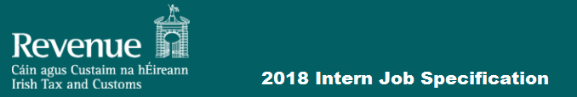

Do you want to work in an organisation that is acknowledged worldwide as being one of the most innovative and successful users of information and communications technology both in the Public and Private Sector?
Do you want to create digital services for our customers involving the Cloud, Mobile Apps, Geographic Information Systems, Predictive Analytics and advanced Business Intelligence built using cutting-edge technologies such as complex data modelling, rules engines, data-grids, in-memory databases and a range of commercial and open source tools such as Spring, Hibernate, Hadoop, Angular JS, J-Query and many more?
Do you want to learn about the international software standards we use in building and testing our solutions and running our Data Centres?
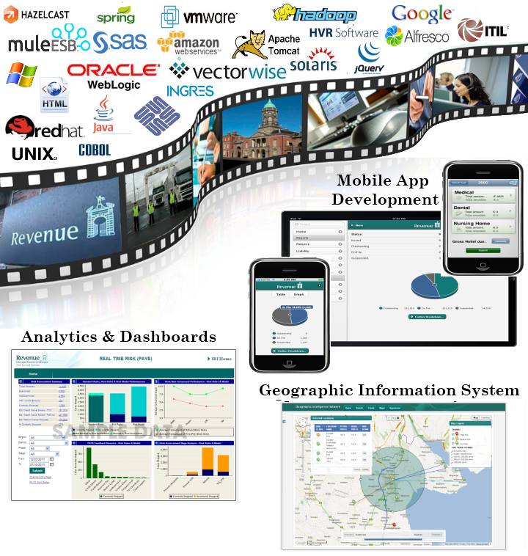
About the Revenue Commissioners
The mission of the Office of the Revenue Commissioners is to serve the community by fairly and efficiently collecting taxes and duties and implementing import and export controls. With over 5,800 staff, almost 2.5 million personal and business taxpayers and a responsibility for collecting in the order of €47 billion per annum in net taxes and duties as well as trade facilitation and frontier control, the Revenue Commissioners have truly embraced technology to the extent that Ireland has again been ranked as the easiest country in Europe in which to pay business taxes.
What type of work can you expect to be doing?
Revenue has always viewed ICT as a catalyst and potential mould breaker in addition to the more classic ‘business demand - technology supply’ model. It provides the fundamental underpinning to Revenue’s business operations. ICT has and will play a pivotal role in driving efficiency and quality improvements within Revenue and it will be at the heart of reducing labour-related processing and contact costs, and of getting an increased return from our compliance, audit and enforcement activities.
Technically, we use a blend of proprietary and open source technologies to deliver business solutions, augmented where available by commercial off-the-shelf packages.
Staff in the ICT Division of Revenue work across a broad range of disciplines and as an intern, you can expect to work on exciting projects and experience one or more of the following:

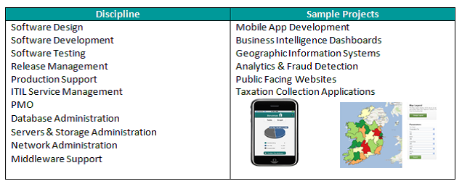
Skills Required
- Basic understanding and knowledge of Software Delivery Methodologies.
- Excellent communication skills (verbal and written).
- Willingness and self-motivation to learn and take on challenging opportunities.
- Ability to work in a team-oriented environment.
Job conditions
Posts will be located in Dublin.
The salary will be based on the Executive Officer starting point, which is currently €27,464 per annum.
Hours of attendance will be 37 hours per week. Flexible working hours are available.
The annual leave allowance for the period of the employment with Revenue will be approximately 11 days.

